Lane timer sheets – just watch out before you print your lane timer sheets
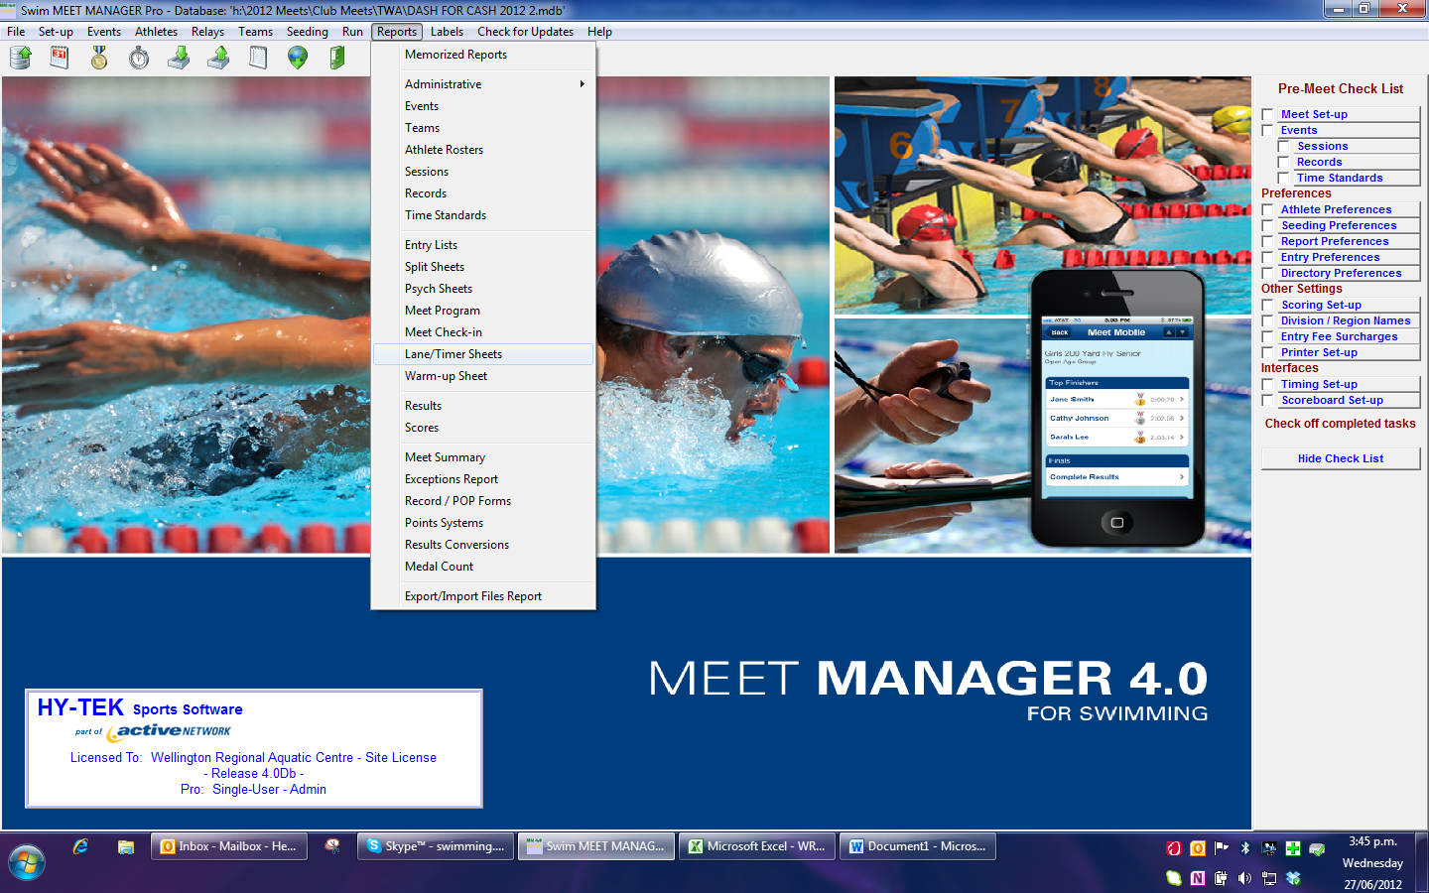

Select all events you will notice the lane allocation below as 1-10 this must be changed to
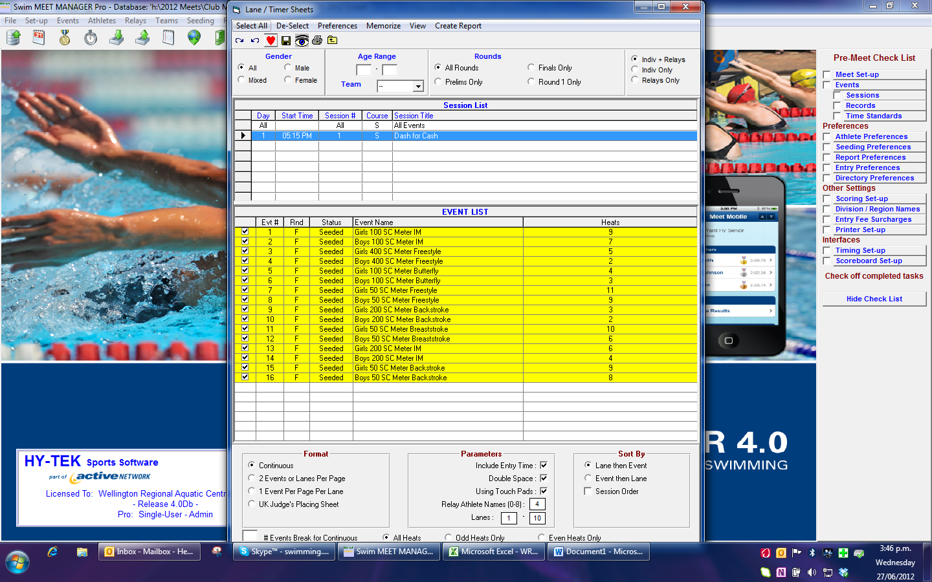

Then ensure you change this otherwise you will need to re-print
